**What is Zawjen.net core?**

Charity

Love

Knowledge

words

light

**What type of Datasets Zawjen.net deals?**

**Truth**

Green

**Lie**

Red

**Doubtful**

Yellow

**3. Green Content for Kids, Adults & Elderly**

**4. Millions of Green Datasets**

**2. Share Knowledge & Love**

**Zawjen.net Vision Summary**

**1. Study in Nature**

**4. Share Green Knowledge**

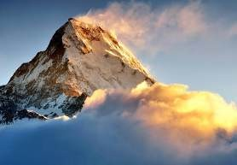

**3. Green Content for Kids, Adults & Elderly**

Build green content loved by various age groups, genders, and communities around the world.

**2. Share Knowledge & Love**

If we are 1 billion people and each owns a piece, together we don't own 1/billion but a full billion by the virtue of knowledge, caring, and love.

**4. Millions of Green Datasets**

Build searchable datasets for all fields of life and connect them together in one tool.

**4. Share Green Knowledge**

Provide search and filter capabilities on knowledge clearly tagged as Green, Yellow or Red.

**1. Study in Nature**

Communities worldwide go to nearby natural signs of love like seas, rivers, mountains and share green knowledge, eat together



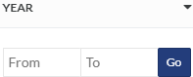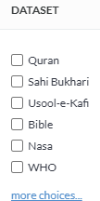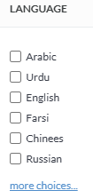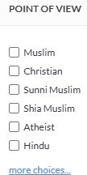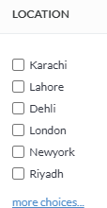

**Filters**

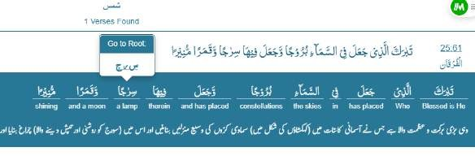

**Dataset 1**

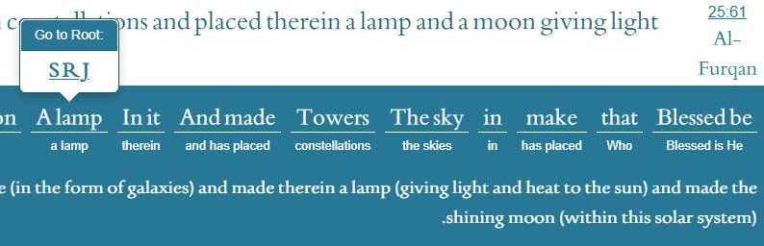

**Dataset 2**



**Sponsored Nature Study Tour**

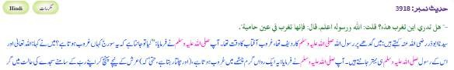

**Hadith Dataset**

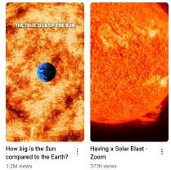

**Video Datset**

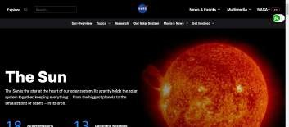

**Nasa Dataset**

**Dataset 1**

# Dataset Types

**Filters**

**Dataset 2**

**Dataset 3**

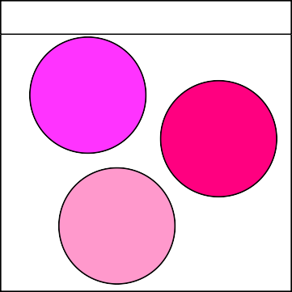

**Dataset Types**

Text

Video

Audio

word 1 word 2 word 3

**Text Dataset 1**

Religion, Politics, Virology, Criminology, Military, Medicine, Agriculture, Education, Economics, Law, Psychology, Sociology, Technology, Engineering, Food Science, Environmental Science, Transportation, Communication, Public Health, Housing, Energy, Water Resources, Trade, Governance, Disaster Management.

# Word Categories

dictionary category attributes pictures videos audios

**Word Page**

meeting with experts

study tour

People, Places, Fruits, Animals, Birds, Angels, Jinn, Events, Miracles, Laws, Ethics, Historical Stories, Natural Elements, Religious Concepts, Spiritual Terms, Rivers, Mountains, Cities, Countries, Tribes, Prophets, Kings, Teachings, Punishments, Prayers, Charity, Fasting, Worship, Heaven, Hell, Creation, Commandments, Signs of God, Resurrection, Judgment Day, Wisdom, Parables, Metaphors, Symbols, Blessings, Punishments, Divine Revelation, Prophecies, Covenant, Sin, Repentance, Forgiveness, Mercy, Justice, Light, Darkness, Good, Evil, Truth, Falsehood, War, Peace, Love, Patience, Gratitude, Humility, Pride, Hypocrisy, Faith, Knowledge, Guidance, Struggle, Trials, Tests, Success, Failure, Sacrifice, Obedience, Disobedience, Leadership, Kingdoms, Nations, Holy Books, Sacred Sites, Prayer Locations, Idolatry, Righteousness, Piety, Brotherhood, Family, Marriage, Inheritance, Trade, Economy, Wealth, Poverty, Orphans, Widows, Charity, Bribery, Oppression, Liberation, Slavery, Free Will, Destiny, Signs of the End Times, Angels’ Duties, Divine Messages, Sacred Language, Poetry, Songs, Divine Punishments, Healing, Resurrection of the Dead, Afterlife, Intercession, Divine Wisdom, Divine Commands.

# People Attributes

Born, Died, Birth Location, Travel Locations, Death Location, Truthful, Liar, Trustworthy, Weak, Strong, Reliable, Unreliable, Fabricator, Honest, Deceiver, Just, Unjust, Pious, Corrupt, Noble, Dishonorable, Virtuous, Wicked, Intelligent, Foolish, Knowledgeable, Ignorant, Accurate, Mistaken, Firm in Memory, Weak in Memory, Forgetful, Precise, Careless, Righteous, Sinner, Devout, Hypocrite, Straightforward, Suspicious, Confused, Consistent, Inconsistent, Authentic, Forged, Sound in Narration, Defective in Narration, Connected Chain, Broken Chain, Mutasib (Biased), Neutral, Accused of Lying, Accused of Forgery, Fabricates Hadith, Follower of Sunnah, Bid’ati (Innovator), Accused of Heresy, Unknown, Famous, Well-documented, Weak in Hadith, Strong in Hadith, Sheikh, Student, Master, Narrator, Abandoned, Criticized, Praised, Commended, Rejected, Suspected, Accused of Tadlees (Concealing Narrators), Reliable in Hadith, Unreliable in Hadith, Sound Memory, Weak Memory, Writes Hadith, Does Not Write Hadith, Makes Mistakes, Precise Narrator, Weak Narrator, Prolific Narrator, Rare Narrator, Trusted by Scholars, Discredited by Scholars.

**Zawjen.net Modules**

**WordPress Site**

About Zawjen and blog.

**React Site**

Zawjen tool.

**ReactNative App**

Zawjen tool.

**K8 / NestJS Backend**

Zawjen REST API

**K8 / FastAPI Backend**

Zawjen AI REST API

**K8 / Redis**

Zawjen Cache

**K8 / Postgres**

**/ Patroni**

Zawjen SQL Database

**K8 / MongoDB**

Zawjen NoSQL Database

**K8 / Keycloak**

Zawjen Auth / MFA

**K8 / ELK &**

**Prometheus / Grafana**

Zawjen Logging & Realtime monitoring

**K8 / Postal**

Zawjen emails

**Zawjen.net Teams**

|  |  |  |  |
| --- | --- | --- | --- |
| **Dataset**  Identify and build dataset pipeline | **WordPress** | **Web** | **Mobile** |
| **Backend** | **DevOps** | **QA** | **Proof Reading** |
| **Security** | **Digital Marketing** | **Community Support** | **Content Writing** |
| **UX** | **Product Owners** | **Scrum Masters** | **Data Science** |